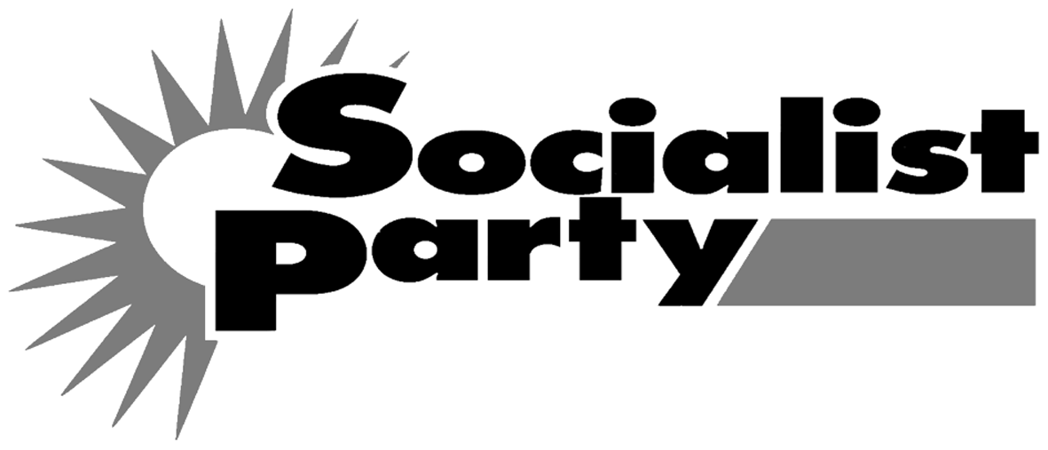
Health Service: Keep it Public!

No to care homes for profit
get the fat cats out!

After wrecking the banking system the financial speculators have now wrecked the social care of the most vulnerable in society. The private equity company Blackstone walked away from Southern Cross Healthcare with £500 million in profit, while 30,000 elderly people are left facing the possibility of being thrown on the streets. Yet the government wants to hand our health service over to private finance as well. We say:
- Immediately take all health and social care services and buildings back into the public sector. Compensation only on the basis of proven need. No compensation to the fat cat speculators!
- For the government to provide the necessary extra funds to local authorities to run care homes.
- Scrap Lansley’s Health and Social Care Bill.
- Rebuild the NHS! No to the cuts – defend workers’ jobs and services!

NAME | ADDRESS | More Info  / Join? | Donation  £
Please return to the Socialist Party, PO Box 24697, London, E11 1YD

